Evidence-Based, High Compliance Procedure
Stethoscope Hygiene Between Patient Encounters:
The Missing Element in a Comprehensive Bundle for Infection Control
Cynthia Cadwell, MSN, RN, CNS, ANP, CPHQ¹, Kathleen Vollman, MSN, RN, CCNS, FCCM, FCNS², Wendy Simpson, MSN, RN, CCRN³, Naomi Ragsdale, BSN, RN³

¹Certified Professional in Healthcare Quality, NP with HPHMG, Honolulu, HI, USA
²Clinical Nurse Specialist & President, World Federation of Critical Care Nurses, Northville, MI, US
³Infection Control Nurse, MEMPHIS VA Medical Center, Memphis, TN, USA

Authors’ Note: Incorporating Stethoscope Hygiene into P&Ps
Over the past decade, mounting evidence has confirmed the stethoscope has been undermining our infection control protocols. In 2022, the guidelines for patient populations at high risk of mortality from hospital-acquired infection (AORN) recognized the stethoscope as a mechanism for pathogen transmission among patients and health care workers, recommending stethoscope hygiene “before use with each patient” as a new standard of care.
This has also been recognized by the CDC, which has proposed elevated guidance for stethoscope hygiene in their draft 2024 Guideline to Prevent Transmission of Pathogens in Healthcare.
In these new guidelines, the stethoscope diaphragm is now recognized as a vector of “transmission via touch.” This new classification comes with the appropriate recommendation that hygiene, similar to hands, is practiced between every patient encounter.
The purpose of this policy & procedure (P&P) template is to introduce an evidence-based, high compliance solution for stethoscope hygiene. The goal is to provide a comprehensive program to ensure hygiene between each patient encounter is achievable in a workflow compatible, cost-effective, and sustainable way that aligns with new CDC guidelines.
This comprehensive, evidence-based template is provided for inclusion into your health system and facility’s Policies & Procedures Manual.

SUBJECT: Infection Control & Healthcare Epidemiology Policies and Procedures
Stethoscope (incorporate into Hand*) Hygiene Policy and Procedure
1.0 Audience and Scope: [Institution] requires adherence to the stethoscope hygiene policy and procedure by all personnel engaged in auscultation in any [institution] facility:
- [List specific personnel if needed]
2.0 Purpose: To prevent the transmission of microorganisms from healthcare provider (*hands and) stethoscope to patients. Effective stethoscope (*and hand) hygiene reduces the risk of infection via transmission of microorganisms between healthcare workers and patients/residents.
3.0 Policy: All members of the healthcare team at {Institution} will comply with current Centers for Disease Control and Prevention (CDC) guidelines for stethoscope (*and hand) hygiene.
- Stethoscope cleaning shall be practiced before and after each shift. All Healthcare providers and staff are required to clean their stethoscopes before initiating patient care and prior to completing their shift.
- Stethoscope diaphragm hygiene shall be practiced before and after each patient contact using the aseptic diaphragm barrier modality.
4.0 Procedure for Cleaning Stethoscope at start and end of shift:
- Use a 70% alcohol wipe to thoroughly clean both the chest piece and headpiece.
  - Pay special attention to the earpieces and diaphragm, as these areas can harbor bacteria.
  - The tubing of the stethoscope can be cleaned using a 70% isopropyl alcohol wipe.
- Ensure the entire stethoscope is dry after disinfecting it.
- Always follow manufacturers’ recommendations for cleaning.

5.0 Procedure for Stethoscope Diaphragm Hygiene Before and After Each Patient Contact:
- Apply the Diaphragm Barrier when it is anticipated that use of the Stethoscope will occur to auscultate the patient, ideally after entering patient room and after handwashing (and gloving if applicable)*.
  - Apply the barrier after handwashing and gloving*, prior to auscultating patient using an aseptic non-touch technique.
  - Apply the single-use aseptic barrier to the stethoscope diaphragm, ensuring a clean contact with the patient.
- Following auscultation of the patient, remove the diaphragm barrier, prior to removing gloves and handwashing, and before exiting the patient area.
  - The single-use aseptic barrier must be removed from the diaphragm and disposed of as with other PPE.
- When auscultating a contaminated area of the body, prior to moving to a clean body site for auscultation, a change of barriers is required, just as is the practice for changing gloves.
- The single-use aseptic barrier should be used only for a single patient examination.

- Technique for Application and Removal of Stethoscope Aseptic Barrier
Approach the touch-free dispenser located on the wall of the patient room:
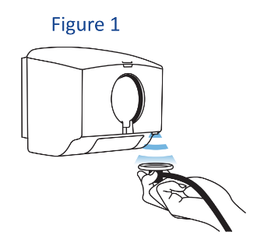

  - ACTIVATE: Hold stethoscope flat & directly under the activation sensor to dispense aseptic disk cover barrier (Figure 1).

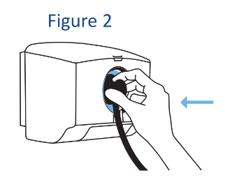
  - APPLY: Press stethoscope gently into application window to apply aseptic disk cover. (Figure 2).

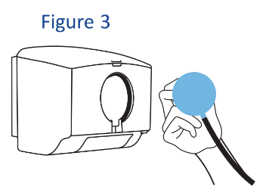
  - AUSCULTATE: Examine patient with clean disk cover applied to stethoscope diaphragm. (Figure 3).

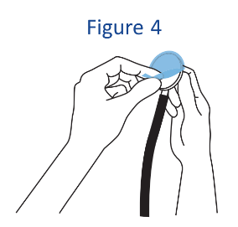
  - REMOVE: Pull peel tab to remove single-use disk cover after exam (Figure 4) and dispose of it appropriately.

General Information on Use of Stethoscope Diaphragm Barriers:

A. The use of stethoscope diaphragm barriers does not replace the need for physical cleaning of the stethoscope at the beginning and end of each daily shift, and when it becomes visibly soiled during a patient interaction.

B. Do not use the same diaphragm barrier to auscultate more than one patient.

C. The cleaning and reuse of the aseptic diaphragm barrier is not recommended. Reuse of the diaphragm barrier represents a risk for pathogen transmission.

Supporting evidence: Center for Disease Control and Prevention, Epidemiology
- Hand (https://www.cdc.gov/mmwr/PDF/rr/rr5116.pdf) (Note: Hand Hygiene Practices between patients should be followed along with Stethoscope Hygiene)
- New 2024 CDC Stethoscope Hygiene Guidance (https://www.cdc.gov/hicpac/media/pdfs/DRAFT-2024-Guideline-to-Prevent-Transmission-of-Pathogens-2023-10-23-508.pdf)
- Use of Aseptic Diaphragm Barriers: Stethoscope Barriers Narrative Review; It's Time for a Strategy Unfriendly to Multi-Drug Resistant Organisms (MDROs) (https://www.sciencedirect.com/science/article/pii/S1876034124001035?ref=pdf_download&fr=RR-2&rr=8aeaba94bcfb69a6)

